**OPENER EXAMINATIONS TERM 2 YEAR 2021**

**MATHEMATICS PAPER I**

**FORM III**

**Time: 2 ½ hours**

**NAME________________________ADM NO________CLASS_________**

**Instructions**

1. Answer all questions in section I and any five questions in section II
2. Show all your workings in the spacers provided.
3. Use recommended calculator and mathematical tables.

**FOR EXAMINERS USE ONLY**

|  |  |  |  |  |  |  |
| --- | --- | --- | --- | --- | --- | --- |
| 1 | 2 | 3 | 4 | 5 | 6 | 7 |
| 8 | 9 | 10 | 11 | 12 | 13 | 14 |
| 15 | 16 | 17 | 18 | 19 | 20 | 21 |
|  |  |  |  |  |  | TOTAL |
|  |

**SECTION I**

1. Evaluate without using calculator (3mks)
$$\frac{\left(1\frac{3}{7}- \frac{5}{8}\right) x \frac{2}{3}}{\frac{3}{4}+ 1\frac{5}{7} ÷ \frac{4}{7} of 2\frac{1}{3} }$$

2. A two digit number is such that the sum of the ones and the tens digits is ten. If the digits are reversed, the number formed exceeds the original by 54. Find the number (3mks)
3. Simplify (3mks)
$$\frac{{125}^{\frac{2}{3 }} ÷3^{4}}{{243 }^{-\frac{2}{3 }} }$$

4. Find all integral values of x which satisfy the inequalities. (3mks)

2(2 – x) < 4x – 9 < x +11

1. Simplify the expression
$$\frac{p^{2}-{4m}^{2}}{{2m}^{2}-7mp+ {3p}^{2}}$$

2. The sides of a rectangle water tank are in the ratio 1:2:3. If the volume of the tanks is 1024cm3 . find the dimension of the tank. (3mks)
3. The length and width of a rectangle figure is 6.1cm and 5.3cm respectively. Calculate the percentage error in the perimeter of the rectangle (3mks)
4. Find the values of which satisfy the equation. (2mks)

2 *cos* (2β + 30°) = - $\sqrt{3}$ in the domain 0° ≤ β ≤ 360

1. Use logarithms to calculate (3mks
$${\left(\frac{0.5342 x 0.07627}{23.47}\right)}^{\frac{1}{3 }}$$

2. Solve the logarithmic equation below for the value of x (3mks)

Log10 (3*x* + 1) - Log10 (*x –* 2) = Log10 10

1. Given the Sinβ = $\frac{\sqrt{2}}{\sqrt{3}}$. Find the value of $\frac{Tanβ + Sinβ}{Cosβ}$ (3mks)
2. Calculate the missing angles where O is the centre (3mks)

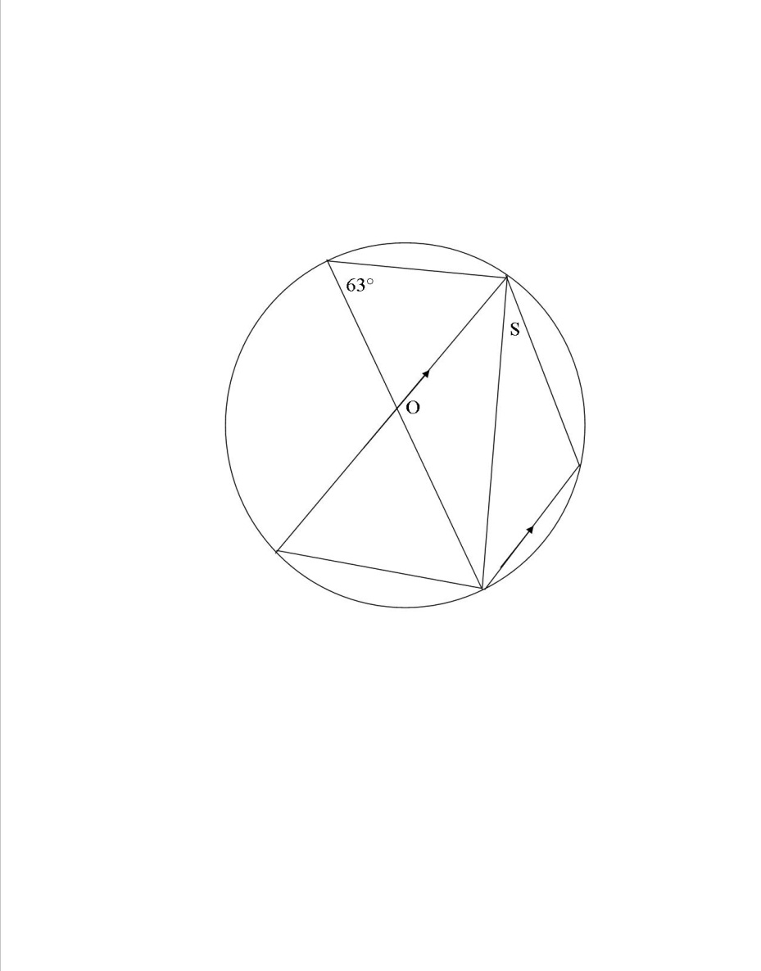

1. Solve using completing square method (3mks)

4*x2* – 12*x* + 9 = 0

1. Calculate the compound interest on sh.9,000 for 2 years at 12.5% p.a compounded half yearly. (4mks)
2. In the figure below, if a circle is drawn passing through A, B and C what would be the radius of the circle (4mks)

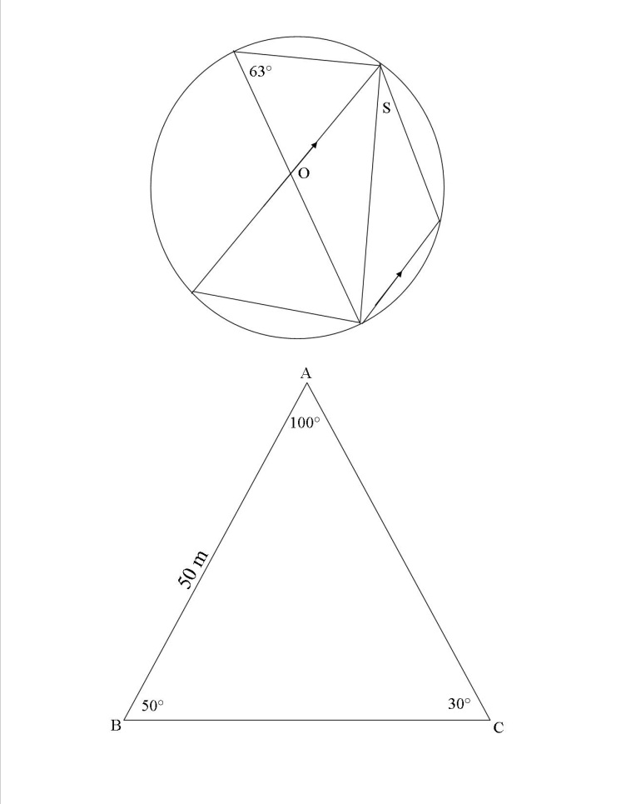

1. A bicycle wheel turns 30 times in covering 132m. find
2. The radius of circle (2mks)
3. Express the speed in km/h (2mks)

**SECTION II**

**ANSWER FIVE QUESTIONS ONLY (50 MARKS)**

1. Income rates for income earned were charged as follows

|  |  |
| --- | --- |
| **Income in kshs. p.m** | **Rates in kshs. Per sh.20** |
| 1 – 8400 | 2 |
| 8401 – 18000 | 3 |
| 18001 – 30000 | 4 |
| 30001 – 36000 | 5 |
| 36001 – 48000 | 6 |
| 48001 and above | 7 |

A civil servant earns a monthly salary of kshs. 19200. His house allowances is ksh.12000 per month. Other allowances per month are transport kshs.1300 and medical allowances kshs.2300. he is entitled to a family relief of kshs.1240 per month. Determine

1. His taxable income per month (2mks)
2. Net tax (4mks)

In addition, the following deductions are made

NHIF – ksh.230

Service charge – ksh.100

Loan repayment – ksh.4000

Cooperative shares – ksh.1200

Calculate his net salary per month (4mks)

1. The diagram represents a solid frustram with a base radius 21cm and top 14cm. the frustram is 22.5cm high and id made of a metal whose density is 3g/cm3. (π=)

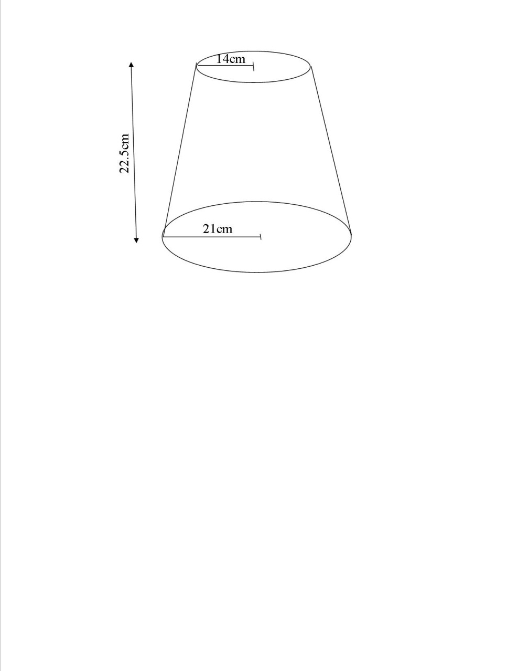

1. Calculate
2. The volume of the metal in the frustram (5mks)
3. The mass of the frustram in kg (2mks)
4. The frustrum is melted down and recast into a solid cube. In the process 20% of the metal is lost. Calculate to decimal places the length of each side of the cube. (3mks)
5. Using a ruler and d pair of compasses only draw a parallelogram ABCD such that angle DAB=75°, length AB=6cm and BC=4cm D drop a perpendicular to meet AB at N.
6. Measure length DN (5mks)
7. Find the area of parallelogram (5mks)
8. The distance between town A and B is 360km. a minibus left A at 8.15 a.m. and travelled towards B at an average speed of 90km/h. A matatu left B two and a third hours later in the same day and travelled towards A at an average speed of 110km/h.
9. i) At what time did the two vehicles meet? (4mks)

ii) How far from A did the vehicles meet (3mks)

1. a motorist started from his home at 10.30a.m on the same day and travelled at an average speed of 100km/h. he arrived at B at the same time as the minibus. Calculate the distance from A to his house. (3mks)
2. A triangle XYZ; x(-1, -1), y(-2,-4) and z(-6,-9) is reflected in the line *x-axis,* to obtain X1Y1Z1, X1Y1Z1 is reflected on the line y=x to obtain X2Y2Z2, X2Y2Z2  is rotated to obtain X3Y3Z3. The rotation is +90° about origin. (10mks)
3. On the grid provided show the objects and the images
4. State the coordinates of the images
5. Complete the table below of the function (10mks)

y=x2 – 5x + 3

|  |  |  |  |  |  |  |  |
| --- | --- | --- | --- | --- | --- | --- | --- |
| x | 0 | 1 | 2 | 3 | 4 | 5 | 6 |
| x2 |  |  |  |  |  |  |  |
| -5x |  |  |  |  |  |  |  |
| 3 |  |  |  |  |  |  |  |
| y |  |  |  |  |  |  |  |

Use your graph to solve

1. x2 – 5x + 3=0
2. x2 – 5x + 3= - 3
3. x2 – 6x + 6=0
4. The angle of depression of a point A on the ground from the top of a post is 18° and that of another point B on the same line as A and nearer to the post is 25°. If A and B are 70m apart.
5. Draw a sketch to represent positions of A and B (2mks)
6. Using your sketch calculate
7. The height of the post from the ground level (1dp) (6mks)
8. The distance of point A from the foot of the post (2mks) \